**Curriculum Vitae**

**of**

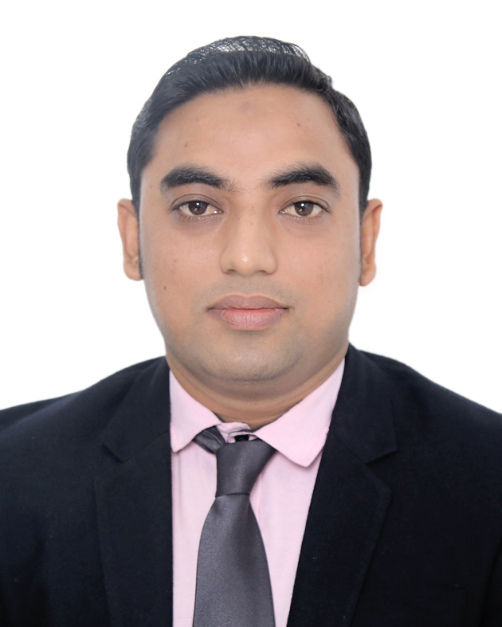

**MD. YASIR ARAFAT**

**Mailing Address:**

C/O: Md. Abul Quashem

Shahanaj Mansion 553 Sheikh Ahmed Munshi

Colony, Mohammedpur, Muradpur, Panchlaish, Chittagong.

Mobile : +88 01812572002

+88 01624244081

Email- [yasir1993raihan@gmail.com](mailto:yasir1993raihan@gmail.com)

Objective

In line with my continued interest and performance Electrical, Electronic and Power Engineering. I have decided to build up my career in the professional field. I am interested to introduce with new technology. I would like to show my immense aspiration to become a quick learner and to prove myself as a sincere and energetic person through extensive hard working and integrity.

Educational Qualification

**B. Sc in Engineering**

Degree : B. Sc in Engineering

Department : EEE

Institute Name : University of Science & Technology Chittagong (USTC)

Board : University of Science & Technology Chittagong (USTC)

Duration of Course : Four Years.

Passing Year : 2021

CGPA : 2.92 (out of 4.00)

**Diploma in Engineering**

Degree : Diploma in Engineering

Department : Power Technology

Institute Name : Chittagong Polytechnic Institute

Board : Bangladesh technical Education Board (BTEB) Dhaka.

Duration of Course : Four Years.

Passing Year : 2012

CGPA : 3.43(out of 4.00)

**Secondary School Certificate (S.S.C)**

Institution name : Baitush Sharaf Ideal kamil Madrasha Chittagong.

Board : Madrasha

Group : Science

Year of Completion : 2008

GPA : 4.75 (out of 5.00)

**Working Experience**

* Now working as a **Junior Officer (Technical)**at the department of **Maintenance** in **Standard Asiatic Oil Company Limited (SAOCL),**(An Enterprise of Bangladesh Petroleum Corporation) **From 01.04.2019 to Till Now.**
* Former **Sub-Assistant Engineer** at the department of **Production and Operation (Double Stand CVC6 Hi Reversing Mill)** in **KYCR Coil Industries Ltd.(KDS Steel Division)** From **01.06.2014** to **25.03.2019**.
* Former **Management Trainee** at the **Department of Maintenance** in **KDS Fashion LTD (KDS Garments Division)** From **03/01/2014** to **31/05/2014** then transferred to **KYCR Coil Industries LTD**.

**Specialization:**

Working at Bangladesh's biggest grease plant erection at SAOCL, Yearly capacity 1000 MT. And also making lubricating oil bleeding kettle, maintenance drum feeling machine, Pail feeling machine and can feeling machine, etc.

**Personal Quality**

* Strong communication skill.
* Hard working.
* Leadership capability.
* Ability to work under pressure.

**Computer Skills**

* Microsoft Word
* Microsoft Excel
* PowerPoint
* Internet Browsing etc.

**Language Proficincy**

* Bengali : Excellent Listening, Reading, Writing and Speaking skills.
* English : Excellent Listening, Reading, Writing and Speaking skills.

**Personal Information**

|  |  |  |
| --- | --- | --- |
| Father's Name | : | Md. Abul Quashem |
| Mother's Name | : | Shahanaj Begum |
| Date of Birth | : | 6th December 1993 |
| Gender | : | Male |
| Marital Status | : | Unmarried |
| Nationality | : | Bangladeshi |
| Religion | : | Islam |
| Permanent Address | : | C/O: Md. Abul Quashem  Shahanaj Mansion 553 Sheikh Ahmed Munshi  Colony, Mohammedpur, Muradpur, Panchlaish,  Chittagong.  **P.S: Panchlaish, P.O: Chandgoan, Dist: Chittagong**. |

**Declaration**

I, the applicant clarify that, according to my knowledge and belief, this Resume correctly narrated my qualifications & no misinformation is given.



Signature

Date :